Bring your own Model in SAP DI

**Step 1: Zip and upload your model**

Zip your saved_model.pb as saved_model.zip

Login to your DI instance’s Launchpad and click on ‘System Management’

Navigate to the Files tab. Create a new folder called Under the Files folder and upload the saved_model.zip file in this folder

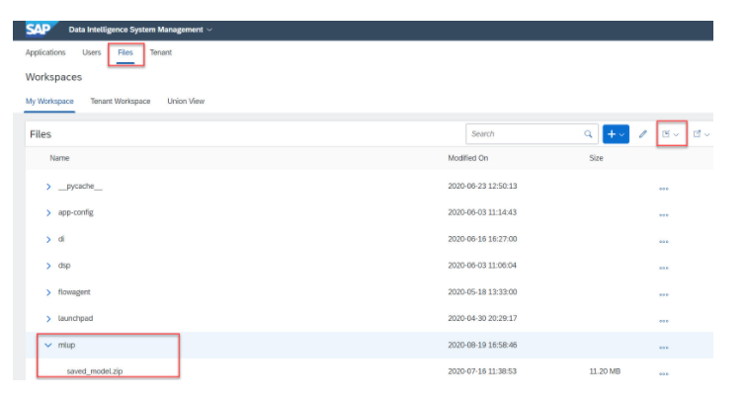

**Step 2:Open Jupyter notebook and use below code to import model and register it**

Now register saved_model.zip with the following code

import os

targetdir = '/vrep/mlup'

files = os.listdir(targetdir)

print(files)

import sapdi

from sapdi.artifact.artifact import Artifact, ArtifactKind, ArtifactFileType

zip_file_path = "/vrep/mlup/saved_model.zip"

artifact = sapdi.create_artifact(

file_type=ArtifactFileType.FILE,

artifact_kind=ArtifactKind.MODEL,

description="Cloud Model pb",

artifact_name="cloudpb",

file_name=os.path.basename('/vrep/mlup/saved_model.zip'),

upload_content=zip_file_path

)

print('Model artifact id {}, file {} registered successfully at {} \n'.format(artifact.artifact_id, zip_file_path,artifact.get_uri()))

output:

Model artifact id b3c65b93-c010-487e-bdc6-243884f110a6, file /vrep/mlup/saved_model.zip registered successfully  
at dh-dl://DI_DATA_LAKE/shared/ml/artifacts/notebooks/exportmodel.ipynb/0d66f14c-c5bc-4c9e-aeed-d0389d1d649f/saved_model.zip